How to connect to Orbiflo TFS

# From Visual Studio 2010

1. Start Visual Studio 2010
2. From the Team Menu, Select Connect to Team Foundation Server

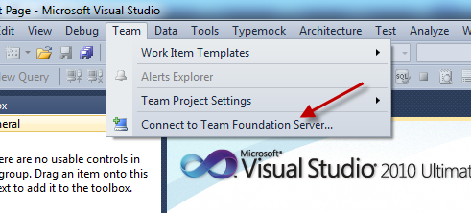

1. Add a new Server

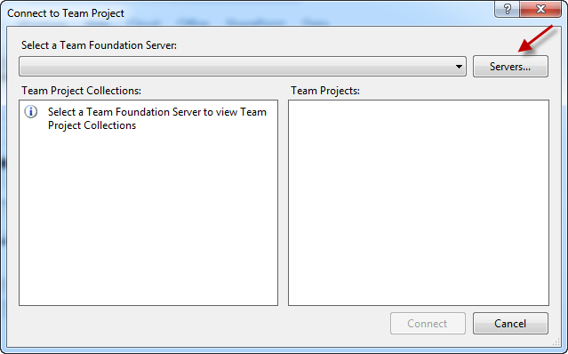

1. Click the Add Button

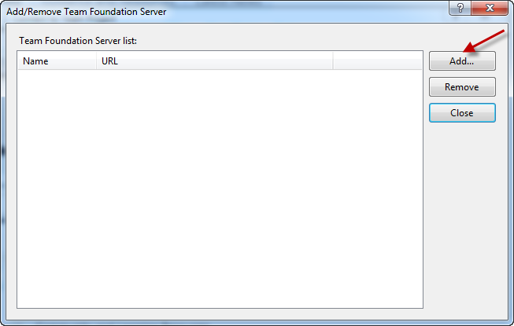

Enter the following values

* 1. Name: tfs.orbiflo-bombardier.com
  2. Path: tfs
  3. Port Number: 8443
  4. Protocol: https

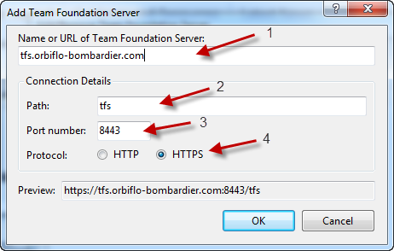

1. Click Ok
2. You will be prompted for you credentials, use the one sent to you to connect to the ORBIFLO TFS server in the form
   1. <Domain>\<user> where Domain = ORBIFLO
   2. Password
3. If you can now see the server in your list of servers click the Close button. If you get an error you used either the wrong credentials or you are not allow to connect to the TFS server

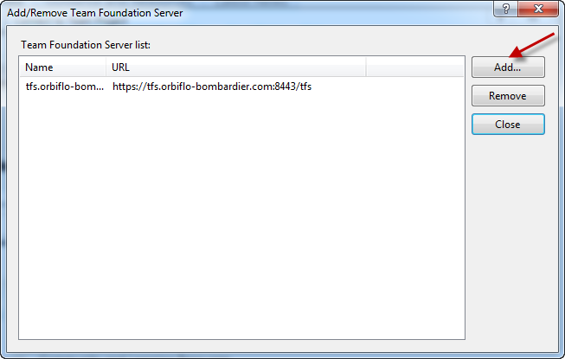

1. After you hit Close you will see the collection you are allowed to connect to

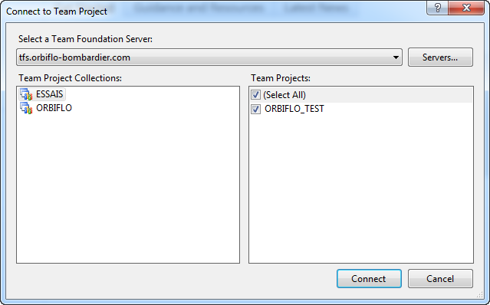

1. After selecting the project you will have a new sidebar in Visual Studio where you will see all the information about the project

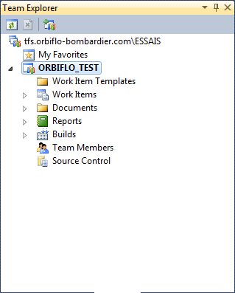

# Connecting using Visual Studio 2005 or 2008

To connect to Orbiflo TFS using older version of Visual Studio Client, you’ll need to install specific patches and products for each of them

## Visual Studio 2005

You first need to install Visual Studio 2005 Team Explorer if you don’t already have it. It’s available at this address

<http://www.microsoft.com/downloads/en/details.aspx?FamilyID=46473c2a-bb85-4461-bb27-4792a5def222>

You then need to install Visual Studio 2005 SP1 to patch both Visual Studio and Team Explorer you can get it at this address

<http://www.microsoft.com/downloads/en/details.aspx?FamilyID=BB4A75AB-E2D4-4C96-B39D-37BAF6B5B1DC>

Next you need to install the Forward compatibility patch for Team System 2010 you can get it at this address

<http://www.microsoft.com/downloads/en/details.aspx?FamilyID=22215e4c-af6f-4e2f-96df-20e94d762689&displaylang=en>

When you try to connect to TFS, follow the same steps as above with these changes

In step 2. You will find the connect to TFS in the tools menu instead of the team menu

In step 5. There will not be a Path field so you need to enter the full address of the TFS server in the Name field like this: [https://tfs.orbiflo-bombardier:8443/tfs/<collection](https://tfs.orbiflo-bombardier:8443/tfs/%3ccollection)> where collection will be the collection you are trying to connect to. In the example above it would have been ESSAIS.

## Visual Studio 2008

You first need to install Visual Studio Team Explorer 2008 if you don’t already have it. It’s available at this address

<http://www.microsoft.com/downloads/en/details.aspx?FamilyID=0ed12659-3d41-4420-bbb0-a46e51bfca86>

Next you will need to install Visual Studio 2008 SP1 to patch both Visual Studio and Team Explorer you can get it at this address

<http://www.microsoft.com/downloads/en/details.aspx?FamilyID=FBEE1648-7106-44A7-9649-6D9F6D58056E>

Finally you will need to install the Forward Compatibility patch for Team System 2010 available at this address

<http://www.microsoft.com/downloads/en/details.aspx?FamilyID=CF13EA45-D17B-4EDC-8E6C-6C5B208EC54D>

When you try to connect to TFS, follow the same steps as above with these changes

In step 2. You will find the connect to TFS in the tools menu instead of the team menu

In step 5. There will not be a Path field so you need to enter the full address of the TFS server in the Name field like this: [https://tfs.orbiflo-bombardier:8443/tfs/<collection](https://tfs.orbiflo-bombardier:8443/tfs/%3ccollection)> where collection will be the collection you are trying to connect to. In the example above it would have been ESSAIS.

## Other client that support the MSSCCI protocol

Example of clients that work with this

• Visual Studio .NET 2003

• Visual C++ 6 SP6

• Visual Visual Basic 6 SP6

• Visual FoxPro 9 SP2

• Microsoft Access 2007

• SQL Server Management Studio

• Enterprise Architect 7.5

• PowerBuilder 11.5

• Microsoft eMbedded VC++ 4.0

Download and install Visual Studio 2010 Team Explorer available at this address

<http://www.microsoft.com/downloads/en/details.aspx?FamilyID=fe4f9904-0480-4c9d-a264-02fedd78ab38>

Download and install Visual Studio 2010 SP1 available at this address

<http://www.microsoft.com/downloads/en/details.aspx?FamilyID=75568AA6-8107-475D-948A-EF22627E57A5>

Finally download and install the MSSCCI power tool for Team System 2010 available at this address

<http://visualstudiogallery.msdn.microsoft.com/bce06506-be38-47a1-9f29-d3937d3d88d6>

# Connecting to the Orbiflo TFS SharePoint Top level Site

You can navigate to this address to navigate to the top level site. This site is not a team project site and can be open or restricted to certain people.

Address: <https://tfs.orbiflo-bombardier.com>

# Connection to an Orbiflo TFS Team Project site

There are two ways to connect to a team project SharePoint site

You can navigate directly to the address if you know it. It is usually in the form

Address: [https://tfs.orbiflo-bombardier.com/sites/<Collection>/<TeamProject](https://tfs.orbiflo-bombardier.com/sites/%3cCollection%3e/%3cTeamProject)> where Collection is the collection your team project lives in and the TeamProject is it’s name, so for example to go to the team site of the ORBIFLO_TEST team project in collection ESSAIS the address would be

Address: <https://tfs.orbiflo-bombardier.com/sites/ESSAIS/ORBIFLO_TEST>

You will be prompted for your ORBIFLO domain credentials

The second way is from Visual Studio, you can right-click on the team project in Team Explorer and select “Show Project Portal…”

